California Association for Nurse Practitioners
SD North Chapter Swag for Sale

We have swag for sale to help us make $$ for the Chapter and for PAC donations.

T-shirts: Women’s and Men’s Huffy style

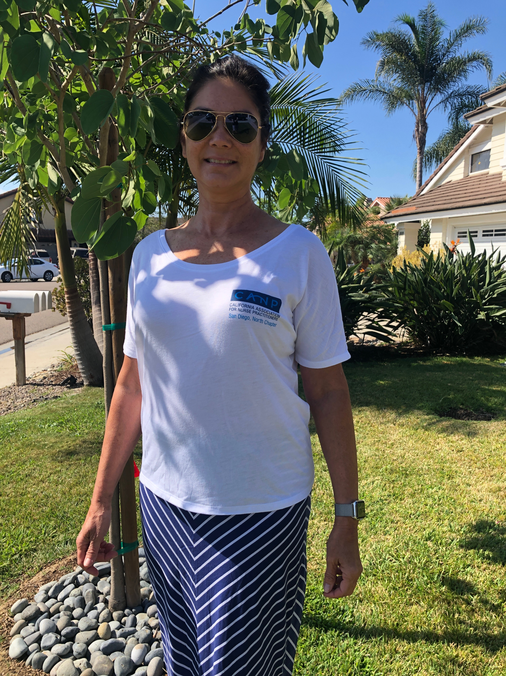

Price:
$10 cash
$12.50 electronic sale (Venmo, Paypal or Zelle)
$15.00 by mail – check or electronic payment

Coolers: These are great! Copper inside so stays hot or cold and has an insert to hold a nice cold bottle.

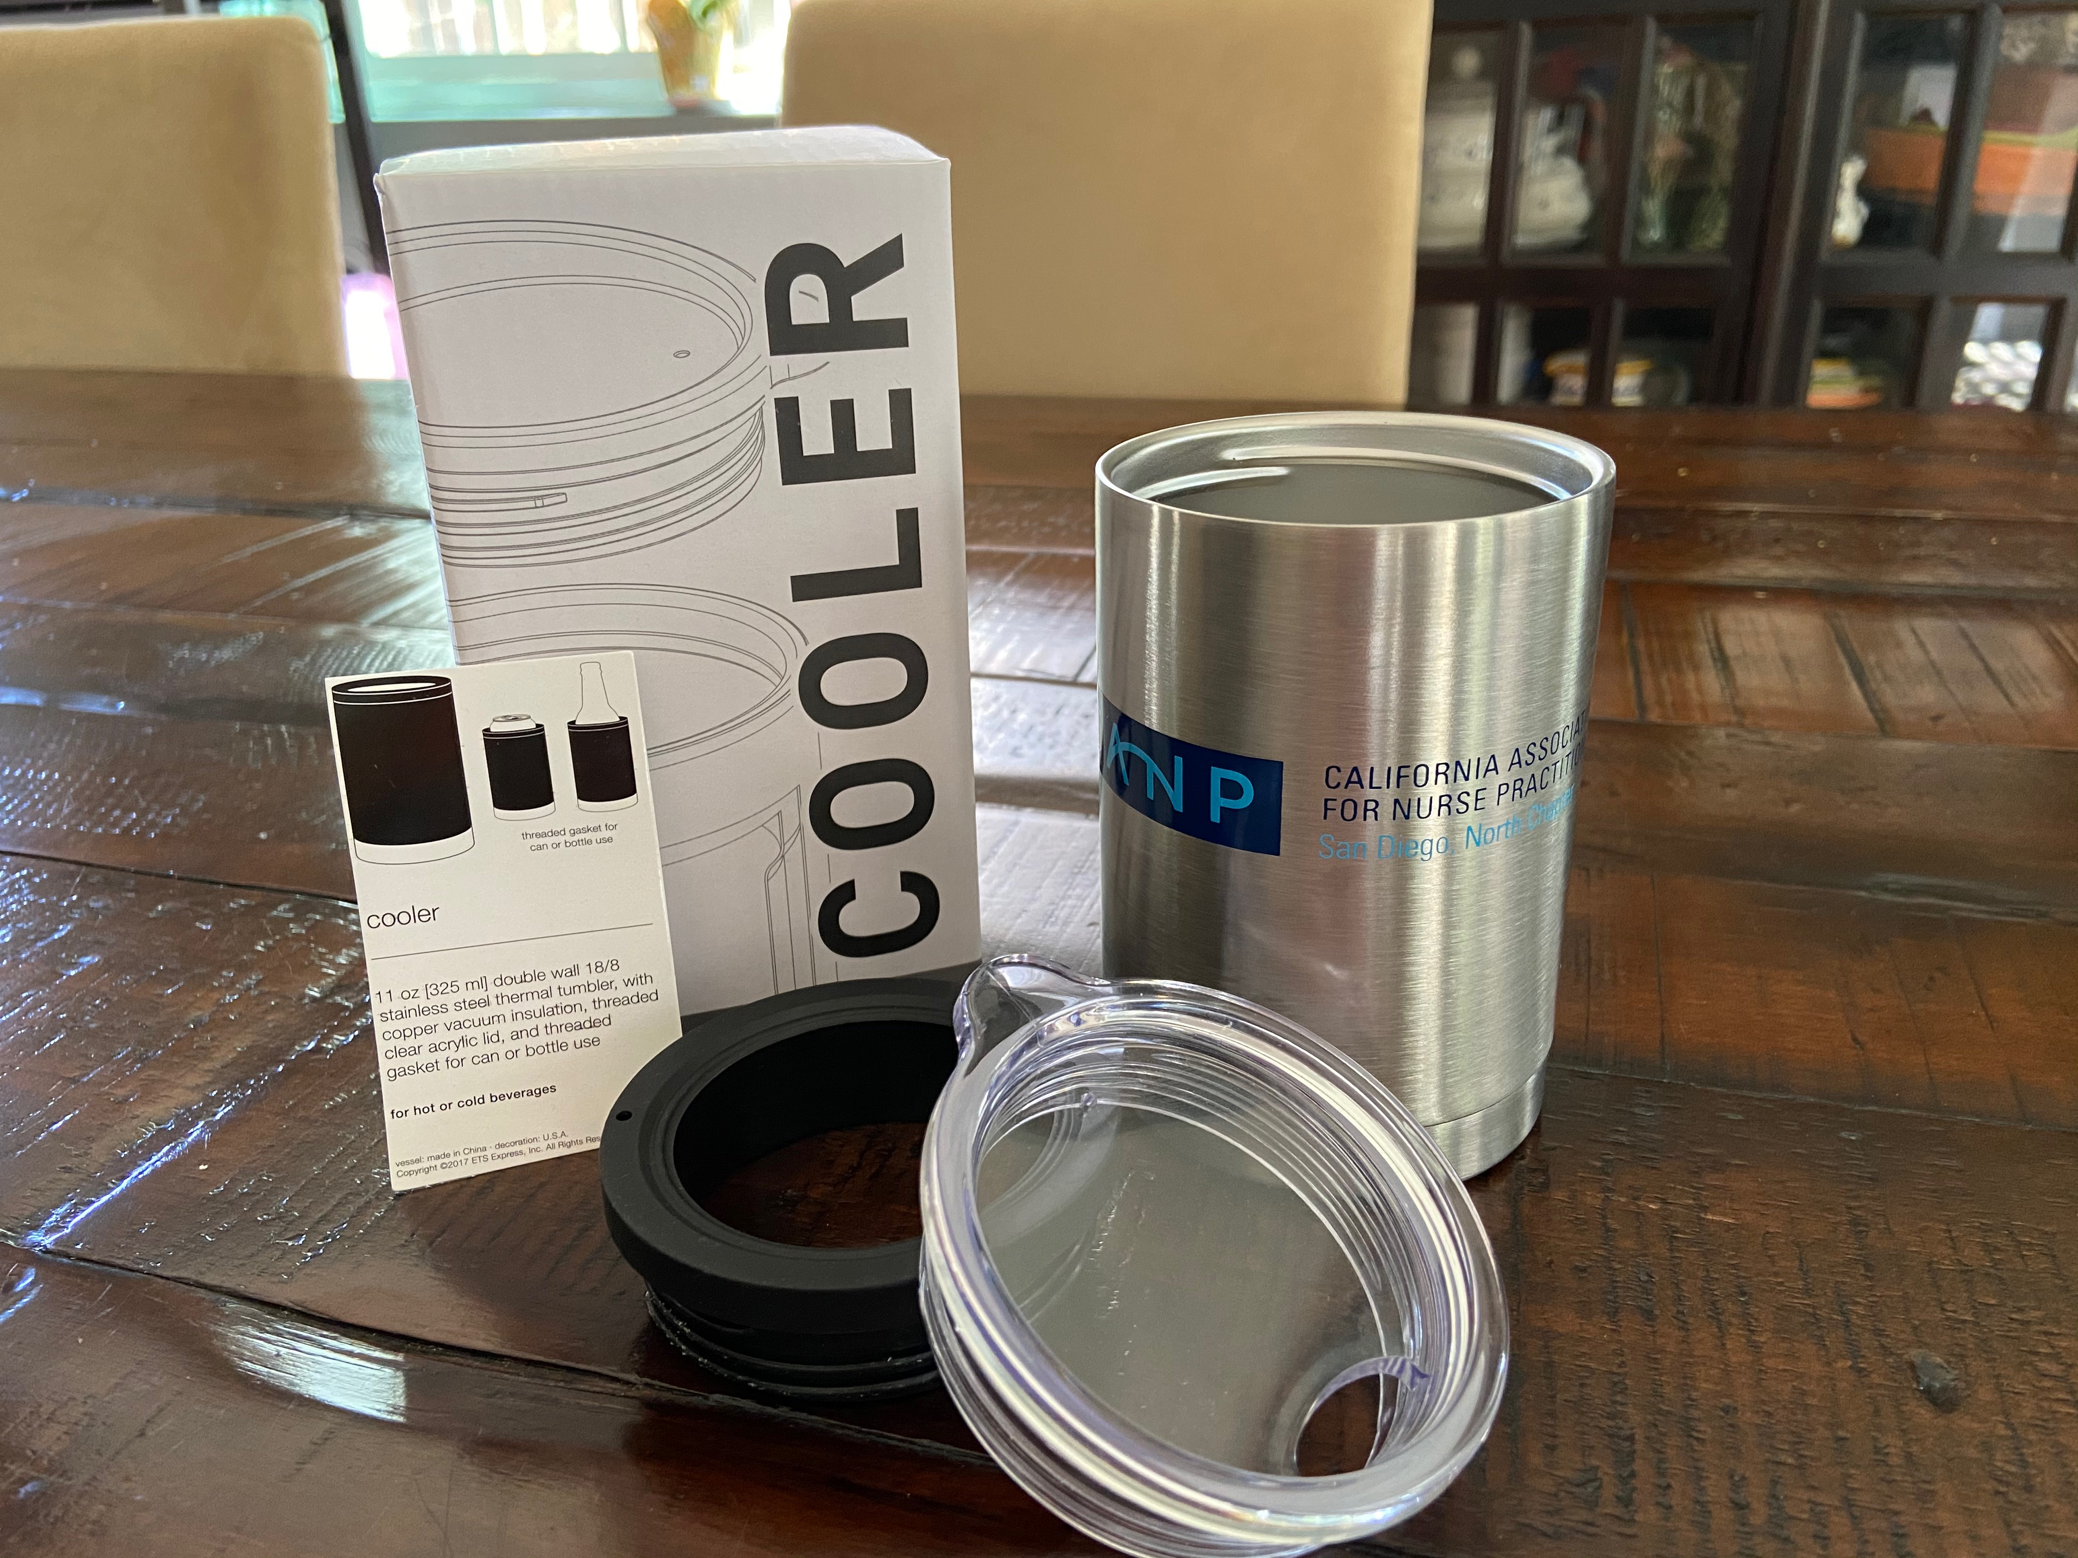

Price:
$15 cash
$17.50 electronic sale (Venmo, Paypal or Zelle)
$19.00 by mail – check or electronic payment

